**Assignment No 01**

**Question:** Create an infograpgic illustrating the Test-Driven Development (TDD) process. Highlight steps like writing tests before code, benefits such as bug reduction, and how it fosters software reliability. also advantage disadvantage

**Flowchart for TDD:**

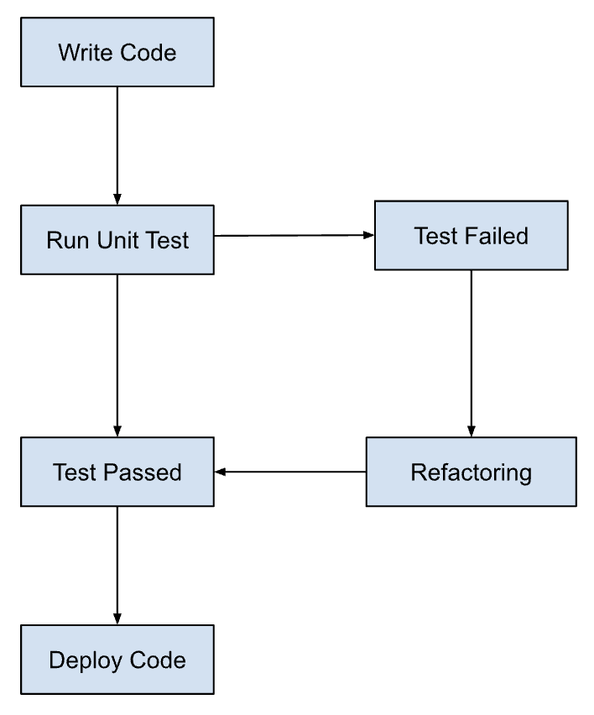

**Step 1:** Start

**Step 2:** Write a Test

Write a test that defines a function or improvements of a function

**Step 3:** Run unit Test

Initially, the test should fail (Red phase)

**Step 4:** Run the Test Again

Check if the test passes (Green phase)

**Step 5:** Refactor Code

Improve the code while ensuring all tests still pass (Refactor phase)

**Step 6:** Test passed

Verify that all tests pass

**Step 7:** Is Test Suite Complete?

If no, go back to writing a new test

If yes, end the process

**Benefits of TDD:**

1. **Reduces Bugs**: Writing tests before code helps catch bugs early in the development process.
2. **Increases Code Reliability**: Continuous testing ensures that new code does not break existing functionality.
3. **Encourages Simplicity**: Forces developers to write only the necessary code to pass tests.
4. **Provides Documentation**: Tests serve as documentation for the codebase.

**Advantages:**

1. **Ensures Code Quality**: Continuous testing improves overall code quality.
2. **Facilitates Refactoring**: Makes it easier to refactor code without fear of breaking functionality.
3. **Improves Design**: Encourages better software design by making developers think about requirements before implementation.

**Disadvantages:**

1. **Time-Consuming**: Writing tests and code iteratively can be time-consuming.
2. **Requires Skill and Discipline**: Effective TDD requires a high level of skill and discipline.
3. **Initial Overhead**: The initial setup and learning curve can be high.